

A Project Report

On

**“Smart body posture recognition and Guiding system”**

Batch Details

|  |  |  |
| --- | --- | --- |
| Sl. No. | Roll Number | Student Name |
| 1 | 20211CCS0124 | Sanketh S |
| 2 | 20211CCS0133 | Mohan C V |
| 3 | 20211CCS0140 | Manu K |
| 4 | 20211CCS0158 | Shaun Franklyn |
| 5 | 20211CCS0190 | V Vishwa Kiran Reddy |

**School of Computer Science,**

**Presidency University, Bengaluru.**

Under the guidance of,

Ms.Sterlin Minish T N

School of Computer Science,

Presidency University, Bengaluru

**CONTENTS**

1. Introduction about Project
2. Literature Review
3. Objectives

## Methodology

1. Timeline for Execution of Project
2. Expected Outcomes
3. Conclusion
4. References
5. **Introduction**

In today’s fast-paced world, self-service health monitoring systems, such as wellness KIOSKs, are gaining popularity. These KIOSKs provide a convenient and accessible way for users to measure vital health parameters like Body Mass Index (BMI), Bone Mass Composition (BMC), Blood Pressure (BP), Electrocardiogram (ECG), pulse, and temperature without the need for professional assistance.

One key challenge with these systems is that accurate measurements depend heavily on the user's body posture. Even slight misalignments, such as an arm positioned incorrectly during a BP measurement, can lead to inaccurate results.

Our project addresses this issue by integrating an advanced posture detection system into the wellness KIOSK. Using a camera and image processing technology, the system captures and analyzes the user’s posture in real time, ensuring the correct posture for each health test. By providing immediate feedback and guidance, the system helps users achieve accurate and reliable measurements.

**Domain Introduction**

In today's rapidly advancing world of healthcare, there is an increasing shift towards automation and self-service solutions, driven by the demand for efficiency and convenience. One such innovation is the integration of technology into health monitoring, where individuals can independently measure their vital health parameters such as BMI, BMC, blood pressure (BP), ECG, pulse, and temperature through non-assisted, automated systems. The goal of such systems is to enable users to proactively monitor their health and make informed decisions without requiring constant medical supervision.

This project falls within the domain of digital health and self-service healthcare technologies, specifically focusing on posture correction during health measurements using self-service kiosks. Ensuring the correct body posture during measurements is critical for accurate results. With advancements in image processing, real-time posture correction using computer vision frameworks such as Mediapipe has emerged as an effective solution. This domain integrates health monitoring, image processing, and user guidance into a seamless system, ensuring reliability and precision in non-assisted healthcare environments.

1. **Literature Review**

|  |  |  |
| --- | --- | --- |
| Sl No | Title | Content |
|  | Damien Brulin, Yannick Benezeth, and Estelle Courtial, “**Posture Recognition Based on Fuzzy Logic for Home Monitoring of the Elderly**”, in IEEE TRANSACTIONS ON INFORMATION TECHNOLOGY IN BIOMEDICINE, VOL. 16, NO. 5, SEPTEMBER 2012 | The proposed system performs human detection prior to the posture analysis; posture recognition is performed only on a human silhouette.The posture recognition method, based on fuzzy logic, identifies four static postures and is robust to variation in the distance between the camera and the person, andto the person’s morphology. |
|  | Biljana Cvetkoska, Ninoslav Marina, Dijana Capeska Bogatinoska, Zhanko Mitreski, “**Smart Mirror E-health Assistant – Posture Analyze Algorithm**” , in IEEE EUROCON 2017, 6–8 JULY 2017, OHRID, R. MACEDONIA | This Model consists of a smart mirror which works on its own algorithm and behaves as smart assistant. This proposed model uses face recognition authentication, posture problem detection, and proper posture guidance, followed with suggestions for preventive healthcare. The algorithm identifies the person’s posture and carefully analyses the posture and body changes over time. |
|  | Jheanel Estrada, Larry Vea, “**Sitting Posture Recognition for Computer Users using Smartphones and a Web Camera**”, in Proc. of the 2017 IEEE Region 10 Conference (TENCON), Malaysia, November 5-8, 2017 | Recognize proper / improper sitting postures using accelerometer readings from some human spinal points through small, thin, and lightweight smartphones attached at those points, and by using a web camera which detects the upper body points’ location and distances. It also established relationships of human body frames and proper sitting posture |
|  | Chia-Feng Juang, Chung-Wei Liang, Chiung-Ling Lee,I-Fang Chung, “**Vision-based Human Body Posture Recognition Using Support Vector Machines**” ,in 978-1-4673-2112-9/12/$31.00 ©2012 IEEE | Vision-based human posture recognition method using a support vector machine (SVM) classifier. Recognition of four main body postures two cameras are used to capture two sets of image sequences at the same time. After capturing the image sequences, a RGB-based moving object segmentation algorithm is used to distinguish the human body from background. Two complete and corresponding silhouettes of the human body are obtained. The Discrete Fourier Transform (DFT) coefficients and length-width ratio are calculated from horizontal and vertical projections of each silhouette. Finally, these features are fed to a Gaussian-kernel-based SVM to recognize postures. Experimental results show that the proposed method achieves a high recognition rate. |
|  | Ling Xie, Xiao Guo, “**Object Detection and Analysis of Human Body Postures Based on TensorFlow**” , in 2019 IEEE International Conference on Smart Internet of Things (SmartIoT) | Human pose estimation algorithm called OpenPose has been more widely used. But its efficiency is very low. We used deep learning methods based on TensorFlow to recognize human body postures.designed eight sets(MobileNet V2,Inception V2,Inception V2, ResNet101,ResNet152, Inception_ResNet_v2,YOLO) of experimental schemes through combining the classification model and the detection algorithm. |

1. **Objectives**

* **Develop a Non-Assisted Wellness Kiosk:**

To design and implement a self-service wellness kiosk that enables users to measure vital health parameters like BMI, BMC, BP, ECG, Pulse, and Temperature without the need for external assistance.

* **Ensure Accurate Health Measurements:**

To improve the accuracy of vital health measurements by guiding users to adopt correct body postures using real-time image processing and posture analysis techniques.

* **Utilize Mediapipe for Posture Detection:**

To leverage the Mediapipe framework for detecting key body landmarks and ensuring that users maintain the correct posture during health tests.

* **Provide Real-Time Feedback:**

To develop a system that can analyze user posture in real-time and offer immediate feedback, either visual or auditory, to correct deviations from the required posture for each health test.

* **Enhance User Experience through Automation:**

To create a user-friendly and fully automated system that facilitates seamless operation, ensuring that users are accurately guided through the process without requiring assistance from medical personnel.

* **Implement a Flexible Posture Correction System:**

To develop a posture correction mechanism that can adapt to various users' body types and health tests, providing tailored posture corrections based on individual deviations.

* **Improve Health Awareness:**

To promote better health awareness by educating users on the importance of correct posture during health tests, contributing to more accurate monitoring and healthier lifestyle practices.

1. **Methodology/Modules**

* **Image Capture and Processing Module**

*Overview*:

This module captures images of the user's posture using an integrated camera system and processes them using computer vision techniques.

*Features*:

Utilizes the Mediapipe framework for landmark detection of key body parts (e.g., hands, legs, torso).

Extracts posture-related features such as the angle of joints and alignment of body parts.

* **Posture Analysis and Guidance Module**

*Overview*:

This module is responsible for analyzing the detected body landmarks to ensure that the user's posture is correct during the measurement process.

*Features*:

Reference Axis Calculation: A reference axis is established using the detected landmarks, and the system calculates the angle of deviation from the ideal posture.

Deviation Detection: If the posture deviates beyond a predefined threshold angle, the system provides visual and audio guidance to help the user correct it.

Feedback System: Real-time feedback loop that helps users adjust their posture before taking the measurement, ensuring accurate results.

**Architecture**

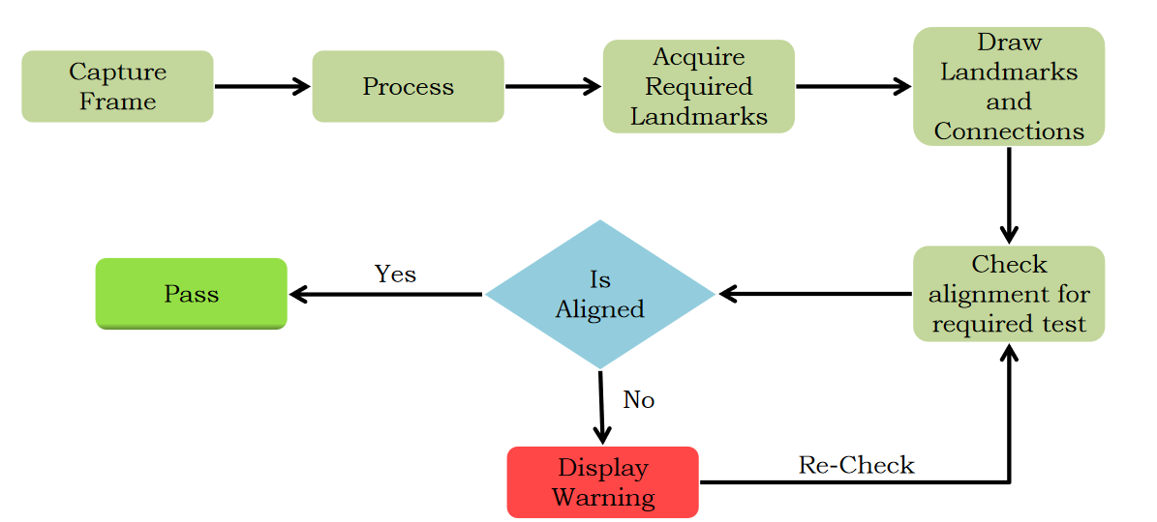

1. **Timeline for Execution of Project**
2. **Expected Outcomes**

* **Accurate Vital Health Measurements**

The system will accurately measure health parameters such as BMI, BMC, BP, ECG, pulse, and temperature, ensuring reliable and precise data collection.

* **Posture Correction Guidance**

The system will detect improper user posture during the measurement process and provide real-time feedback and corrective guidance. This will help users achieve the correct posture for accurate results.

* **Real-Time Feedback and Notifications**

Users will receive immediate feedback about their posture and vital measurements, including visual and audio alerts when corrections are needed or when the test is successfully completed.

* **Increased Measurement Accuracy**

By ensuring that users maintain the correct posture, the system will reduce measurement errors, providing more reliable health data for better analysis and decision-making.

1. **Conclusion**

The development of a self-service wellness KIOSK that integrates posture correction guidance with vital health parameter measurement represents a significant advancement in non-assisted health monitoring systems. By leveraging the Mediapipe framework for posture detection, the system ensures that users maintain the correct posture during tests, leading to more accurate health data. The real-time feedback and correction system further enhances the user experience, enabling individuals to perform measurements without assistance, thus increasing accessibility and convenience.

This project demonstrates how advanced image processing techniques, combined with user-friendly interfaces, can transform healthcare by improving measurement accuracy and offering a seamless, non-assisted user experience. The ability to provide posture correction and vital health data in a single platform can contribute to more effective health monitoring, especially in settings such as public health kiosks, gyms, hospitals, and other self-service environments. Overall, this system has the potential to improve both individual health outcomes and the broader field of wellness technologies.

1. **References**

Reference Papers, <https://ieeexplore.ieee.org/Xplore/home.jsp>

Damien Brulin, Yannick Benezeth, and Estelle Courtial, “Posture Recognition Based on Fuzzy Logic for Home Monitoring of the Elderly”, in IEEE TRANSACTIONS ON INFORMATION TECHNOLOGY IN BIOMEDICINE, VOL. 16, NO. 5, SEPTEMBER 2012

Biljana Cvetkoska, Ninoslav Marina, Dijana Capeska Bogatinoska, Zhanko Mitreski, “Smart Mirror E-health Assistant – Posture Analyze Algorithm” , in IEEE EUROCON 2017, 6–8 JULY 2017, OHRID, R. MACEDONIA

Jheanel Estrada, Larry Vea, “Sitting Posture Recognition for Computer Users using Smartphones and a Web Camera”, in Proc. of the 2017 IEEE Region 10 Conference (TENCON), Malaysia, November 5-8, 2017

Chia-Feng Juang, Chung-Wei Liang, Chiung-Ling Lee,I-Fang Chung, “Vision-based Human Body Posture Recognition Using Support Vector Machines” ,in 978-1-4673-2112-9/12/$31.00 ©2012 IEEE

Ling Xie, Xiao Guo, “Object Detection and Analysis of Human Body Postures Based on TensorFlow” , in 2019 IEEE International Conference on Smart Internet of Things (SmartIoT)

Mediapipe Documentation, <https://pypi.org/project/mediapipe/>